**Assignment: Python Programming for API air pollution**

Name:P.Meghashyam Reddy

Register Number:192372380

Department:CSE(AI)

Date of Submission:26.08.2024

**Problem 5:**

**Air Pollution API**

* Current, forecast and historical air pollution data
* Forecast for 4 days ahead with 1-hour step
* Air Pollution API includes both Air Quality Index and indices for CO, NO, NO2, O3, SO2, NH3, PM2.5, PM10
* Included in both free and paid subscriptions

Deliverables:

* Data flow diagram illustrating the interaction between the application and the API.
* Pseudocode and implementation
* Documentation of the API integration and the methods used to fetch and display the data.
* Explanation of any assumptions made and potential improvements

Solution:

# Air pollution API

# 1.Data Flow Diagram

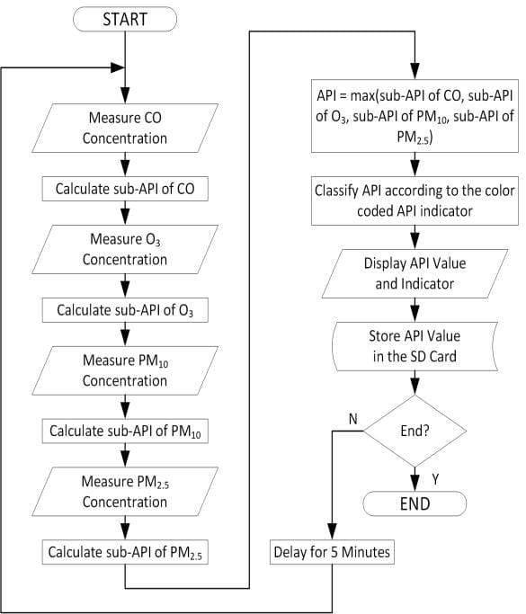

# 2. Implementation

| YOUR CODE  import time  import random  def measure_concentration(pollutant):  return random.uniform(0, 100)  def calculate_sub_api(concentration):  return concentration * 0.5  def classify_api(api_value):  if api_value <= 50:  return "Good"  elif api_value <= 100:  return "Moderate"  elif api_value <= 150:  return "Unhealthy for Sensitive Groups"  elif api_value <= 200:  return "Unhealthy"  elif api_value <= 300:  return "Very Unhealthy"  else:  return "Hazardous"  def main():  while True:  co_concentration = measure_concentration('CO')  o3_concentration = measure_concentration('O3')  pm10_concentration = measure_concentration('PM10')  pm25_concentration = measure_concentration('PM2.5')  sub_api_co = calculate_sub_api(co_concentration)  sub_api_o3 = calculate_sub_api(o3_concentration)  sub_api_pm10 = calculate_sub_api(pm10_concentration)  sub_api_pm25 = calculate_sub_api(pm25_concentration)  api_value = max(sub_api_co, sub_api_o3, sub_api_pm10, sub_api_pm25)  api_classification = classify_api(api_value)  print(f"API Value: {api_value:.2f} - {api_classification}")  print(f"Storing API value {api_value:.2f} to SD card...")  end_process = input("End? (Y/N): ").strip().lower()  if end_process == 'y':  break  time.sleep(5)  if _name_ == "_main_":  main() |
| --- |

# 3.Display the Current information

CO Concentration: 62.88

O₃ Concentration: 22.09PM₁₀

Concentration: 56.65PM₂.₅

Concentration: 89.80API

Value: 44.90

API Classification: Good

# 4.User Input

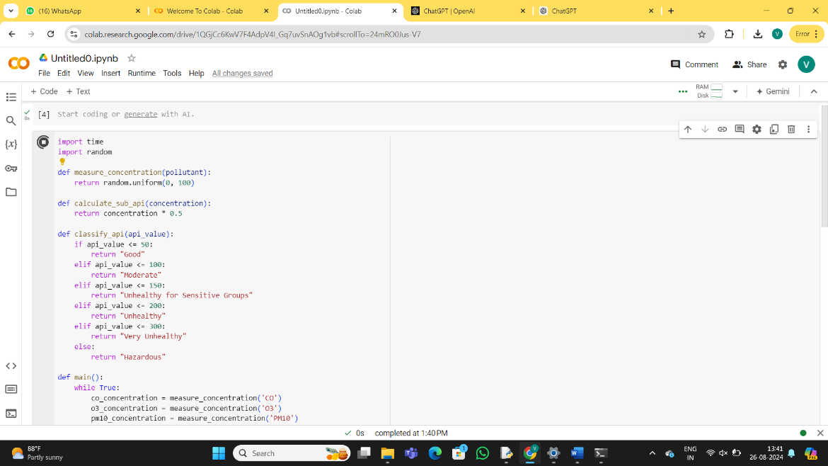

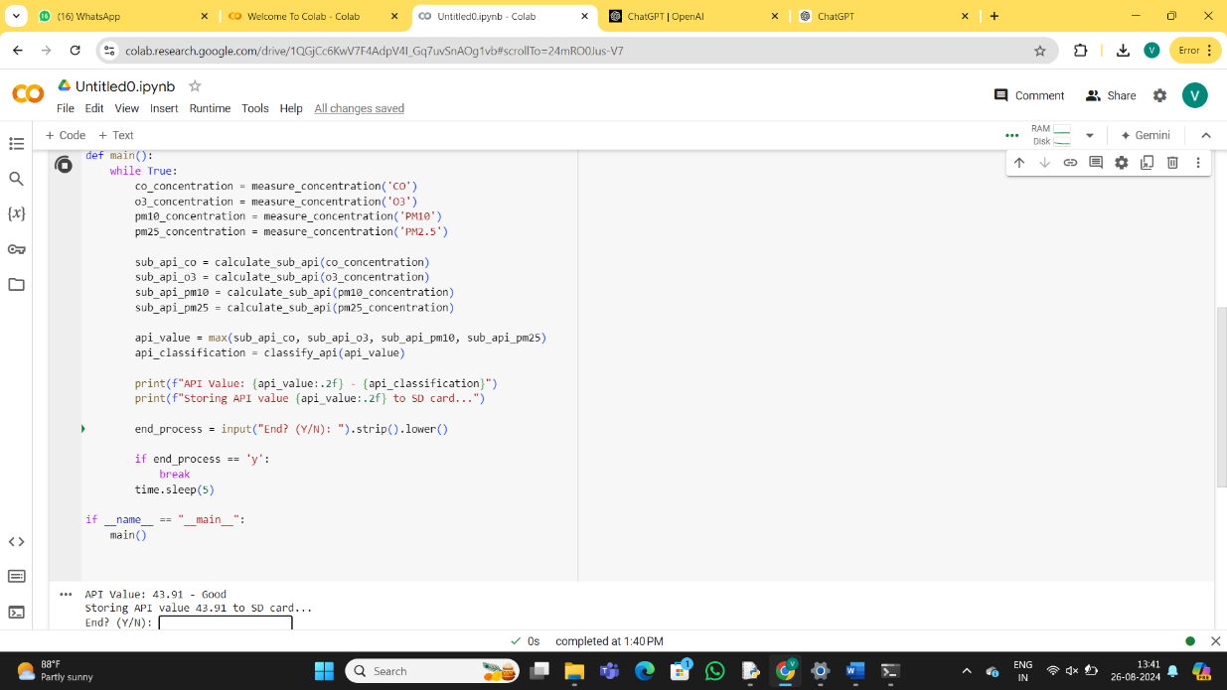

**5.Documentation**

# ALGORITHM

To create an algorithm for an Air Pollution API, you can follow these steps:1. Define the Requirements:Determine the pollutants to monitor (e.g., PM2.5, PM10, NO2, CO, O3).Identify the data source (e.g., government air quality sensors, satellite data).Specify the output format (JSON, XML, etc.).2. API Data Fetching:Initialization API Client: Set up an API client that can send requests to the air pollution data source.Make API Requests: Query the API at regular intervals to fetch current air quality data.

# HOW HISTORICAL DATA INFLUENCES DECISION ON AIR POLLUTION

Impact of Regulations: Governments often implement policies aimed at reducing pollution (e.g., emissions regulations, traffic restrictions). Historical data can be used to evaluate the effectiveness of these policies by comparing air quality before and after implementation.Public Historical data helps in designing public health interventions by understanding the relationship between air pollution levels and health outcomes over time.

**CONCLUSION**

Air pollution is a critical global issue with significant implications for public health, the environment, and the economy. It is driven by various factors, including industrial activities, transportation, urbanization, and natural events, all of which contribute to the degradation of air quality. The use of historical data is essential in understanding the trends, identifying sources, and evaluating the effectiveness of policies aimed at reducing pollution levels. By analyzing past data, we can better predict future air quality, design effective interventions, and raise public awareness about the importance of clean air. Addressing air pollution requires a coordinated effort from governments, industries, and individuals, supported by robust data collection, technological innovation, and strong regulatory frameworks. The ultimate goal is to protect human health and the environment by reducing pollutant emissions, improving air quality, and ensuring a sustainable future for all.